Lab: Creating New Entities

In this lab, you will modify the data model to reflect the creation of a new entity.

Overview

Acme Insurance has a customer requirement that involves tracking information about each interaction that a contact has with Acme (such as a telephone call, an email, a postal mail letter, or an in-person office visit). Acme wants the information displayed in an "Interactions" section of the user interface, as shown below:In this exercise, you will complete the outline tasks.

Tasks

1. Create a new entity named Interaction_Ext. It should capture the following information.**

* ABContact (A foreign key to ABContact which cannot be null)
* Interaction date (A date)
* Initiated by contact (A boolean)
* Summary (A string of up to 60 characters)
* AssociatedUser (A foreign key to User. Because some interactions, such as postal mail, do not involve any Acme employees, this field can be null.)

** Unless noted otherwise, null values are acceptable.

1. Create an array named Interactions on ABContact. The new array should reference the Interaction_Ext entity.

Verification

1. Regenerate the Data Dictionary and verify that the entity and fields are listed (see screenshot below).
2. Deploy your data model changes.

The Entity Relationship Diagram shows how the entities change after you add the new entity.

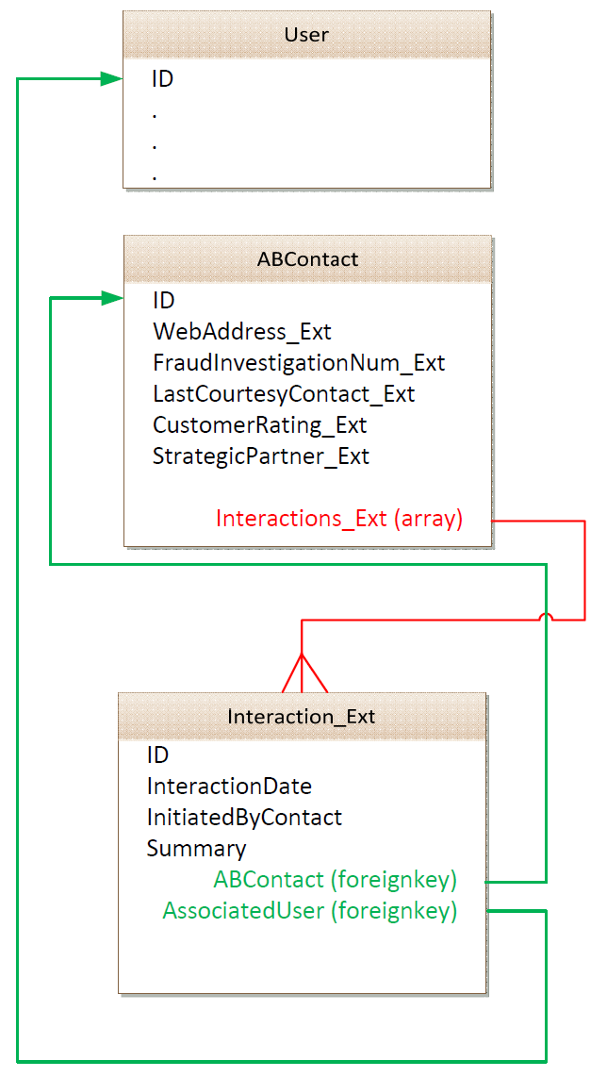

|  |  |
| --- | --- |
|  | Stop and ask your instructor to review your completed lab or verify the new etx file with the solution file. |